Exercises regarding devices used in class (LB p. 23, task 8)

**Description and analysis of the bar graph and relation to the text**

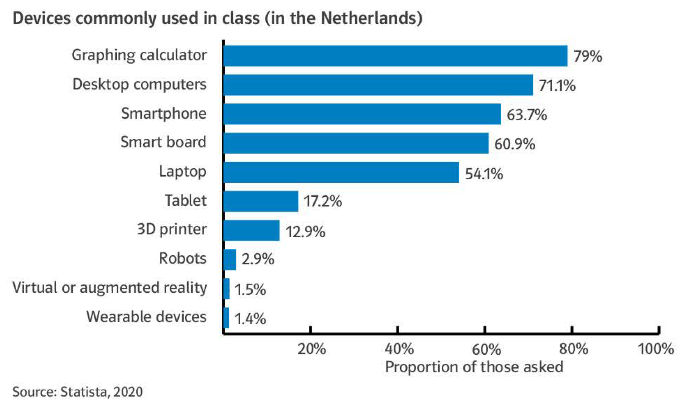

**Exercise: Fill in the gaps.**

The bar graph shows (*show*) which devices are used (*use*) most commonly in the classroom.

The most commonly used (*am meisten benutzte*) device is a graphing calculator at 79%. This may be due to the fact that in many mathematics classes such calculators are mandatory.

The second most commonly used (*am zweit häufgsten benutzte*) device is a desktop computer, at just over 71%, followed by smartphones with almost 64%.

This represents the past being caught up by the present and future. Computers have been in schools for decades, often in computer rooms, but smartphones have risen   
(mehr verwenden) over the last few years, especially now that the majority of students own one.

Laptops are the after that the most used (*danach meist genutzt*) device at 54 % and have already been overtaken by smartphones.

There is then a large gap until tablets at just over 17%. This could be because tablets are newer than (*neuer als … sein*) smartphones and not everyone has one. However, many schools are using them more and more / increasingly (*zumehmend*) in lessons. This number will probably increase in the future and overtake laptops.

Even newer devices (robots, smart watches and VR and AR glasses) are still very much in the experimental phase and therefore only account for (*ausmachen*) less than 5%.

With regard to the critical view of the text on using electronic devices at a too young age (*einem zu frühen Alter*), it is obvious that there are already many different devices used in classrooms, and young people are heavily exposed to (*oft* *konfrontiert sein mit*) many of them. When considering the pros and cons of the different devices used at schools as shown (*wie gezeigt*) in the bar chart, the Waldorf approach makes sense, however, the approach of technology-free learning until the age of 13 (bis zum Alter von 13) seems even more extreme.